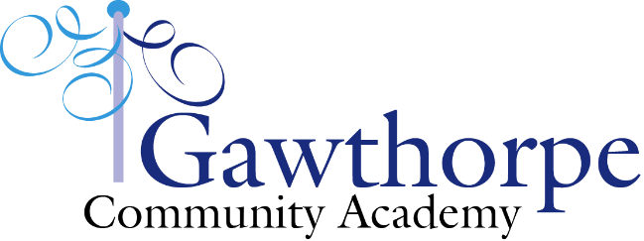

**Gawthorpe Community Academy Parental Code of Conduct**

Here at Gawthorpe Community Academy, we are very fortunate to have a supportive parent body. Our parents place a high value on education and know that they play a vital role in the effective partnership formed between school and home. We are thankful for the positive relationship we have with all our parents and carers and enjoy welcoming you into school to share in all your children’s achievements.

The purpose of this policy is to highlight to all parents, carers and visitors to our school, the expected standards of conduct that ensure these relationships remain positive and enable all children to flourish in a safe and respectful environment.

In addition to the guidance in the home-school agreement, we expect all adults to:

* Respect the ethos of the school
* Demonstrate an understanding that teachers and parents work together for the benefit of children
* Set a good example of speech and behaviour to show respect for everyone o Uphold school behaviour expectations when responsible for their child within the school building or grounds e.g. Supervising children appropriately on the playground prior to school in the morning and not allowing football around waiting adults and children.
* Respect the ban on smoking and dogs within the school grounds.
* Seek support from school to help resolve any issues of concern and never approach other children or their parents to discuss an incident or to chastise another child.
* Direct any concerns you may have about the school through the appropriate channels, which includes the formal complaints procedure should it be needed.
* Demonstrate respect for all children, the school, the staff and other parents by not sharing derogatory, inflammatory or any other negative comments, in speech or by use of social media including Facebook, WhatsApp groups etc.
* Ensure that the area around the school is safe for children to walk to and from school by observing the highway code, parking correctly and driving safely within the appropriate speed limits.

We trust that parents and carers will continue to uphold high standards of conduct at all times to enable school to function well for the benefit of all our children, and we thank you for your continuing support.